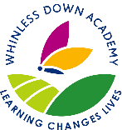

WHINLESS DOWN ACADEMY TRUST
Online resources for home education

This document contains a variety of links to resources that are currently free to use that can support children’s learning at home. They come from guidance provided by the Department of Education which can be found by following this link: https://www.gov.uk/government/publications/coronavirus-covid- 19-online-education-resources

The Department for Education is not the owner or creator of most of the resources listed, and you use all content at your own risk.

Access to resources is in most cases free of charge, but it is your responsibility to check whether you have to pay to view and/or copy specific content contained within the resources.

English
Click on the logo in each box to access the free resource.

Name and link | Age range | Description
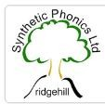 | EYFS KS1 | Find advice, activities, videos, lesson plans and sample pages for reading, spelling and handwriting.
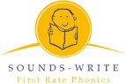 | EYFS KS1 | Lots of online courses and videos for parents, interactive resources, activity workbooks and  games to help learning to read.
 | EYFS KS1  KS2 | All children’s audiobooks are available for free on Audible while schools are closed.
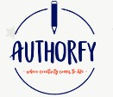 | EYFS KS1  KS2 | Access to masterclasses on texts from a range of authors, including videos from the authors  and activities linked to novels.
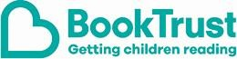 | EYFS KS1 KS2 | A site with recommended booklists, categorised by age range and topic, including fiction and non-fiction. Family activities are  included in the ‘Home Time’ section.

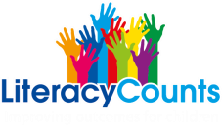 | EYFS KS1  KS2 | Free home learning packs for parents covering reading and writing.
   | EYFS KS1 | Films of well-loved stories read by Nick Cannon, a trained actor, teacher and trainer available Monday, Wednesday and Friday at  2pm.
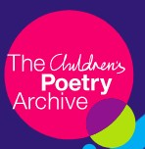 | EYFS KS1  KS2 | An archive of spoken poetry recordings. Children can listen to poems read out loud.
 | KS1  KS2 | Downloadable resource books providing 8  weeks of activities.
 | KS1 KS2 | 3 months free access available to game-based resources covering reading, writing and grammar.
 | KS1  KS2 | Downloadable resource packs with tasks  based on video clips on YouTube.
 | KS1 KS2 | A daily newsletter for parents and carers at home with children, helping to enrich learning  with real-world knowledge and skills.
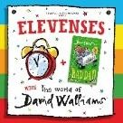 | KS2 | One free audio book reading is available to listen to every day.
 | KS1 KS2 | Interactive resources covering the primary curriculum. Suitable for pupil/parent use.

Maths
Click on the logo in each box to access the free resource.

Name and link | Age range | Description
 | EYFS KS1  KS2 | Downloadable guidance and resource packs for parents and pupils.
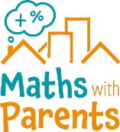 | EYFS | Videos and activities for home-based learning, with resources for both parents and teachers available.
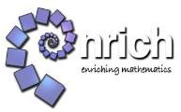 | EYFS KS1  KS2 | A range of activities and articles aimed at students, parents and guardians, and  teachers, categorised into age groups.
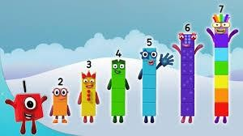 | EYFS KS1 | Videos for numeracy development designed for children aged 0 to 6. There are fun activities that can be applied to everyday life  and play.
 | EYFS KS1  KS2 | A range of interactive maths games categorised by age group, suitable for parents  and students to work through.
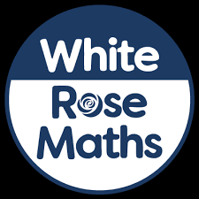 | EYFS KS1 KS2 | Presentations and downloadable workbooks which are easy to use for parents. New material is being released each week.
 | KS1 KS2 | Downloadable resource packs with teacher guidance. A week’s worth of resources is  provided for each year group.
 | KS1  KS2 | Activities and support for learning at home.
 | KS1  KS2 | Games and daily sessions for parents and  students to work through at home.
 | KS2 | Past papers and mark schemes for a range of  key stages.
 | KS1  KS2 | Interactive resources covering the primary  curriculum. Suitable for pupil/parent use.

Science
Click on the logo in each box to access the free resource.

Name and link | Age range | Description
 | KS1 KS2 | Interactive resources covering the primary curriculum. Suitable for  pupil/parent use.
 | KS2 | Online learning courses and assessments covering the key stage 2 science curriculum. Parent sign-up available, suitable for independent pupil use.
 | KS1 KS2 | An online resource bank listing quality- assured resources on external websites.  The site features a live chat function offering support from subject experts. New ‘home learning support for families’  section suitable for parent use.

PE
Click on the logo in each box to access the free resource.

Name and link | Age range | Description
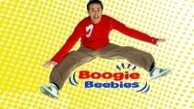 | EYFS KS1 | Videos that get younger children up and dancing with CBeebies presenters.
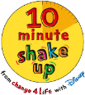 | EYFS KS1  KS2 | 10-minute activities based on Disney films that count towards a child’s 60 active minutes  per day.
 | KS1 KS2 | Videos which help children move while they learn. They support curriculum subjects,  including maths and English.
 | KS1 KS2 | Videos delivered by teachers focussing on the PE curriculum which are accessible on  YouTube.

Wellbeing
Click on the logo in each box to access the free resource.

Name and link | Age range | Description
 | EYFS KS1  KS2 | Wellbeing advice for all those supporting children and young people.
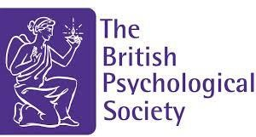 | EYFS KS1  KS2 | Advice on dealing with school closures and talking to children about COVID-19.
 | EYFS KS1  KS2 | A downloadable guide for children about coronavirus.
 | EYFS KS1  KS2 | An educational resource for all adults on children and young people’s mental health.
 | EYFS KS1  KS2 | Advice on supporting grieving children during the coronavirus outbreak.

Special Educational Needs and Disabilities (SEND)
Click on the logo in each box to access the free resource.
Apps and games (apps must be downloaded onto compatible devices)

Name and link | Age range | Description
 | EYFS KS1  KS2 | A visual instruction app, including flash cards and picture-choosing games, for children with  autism and special needs.
 | EYFS KS1  KS2 | A collection of games and resources designed for a range of educational needs and stages. It  includes provision for school closure.
 | EYFS KS1 KS2 | A range of apps are available for pupils with Profound and Multiple Learning Difficulties (PMLD) or Severe Learning Difficulties (SLD). All are interactive and many do not require  significant co-ordination abilities.
 | EYFS KS1  KS2 | An all-in-one app created to support people with communication and learning difficulties.  For verbal and non-verbal learners.

Online, downloadable and printable resources for SEND.

Name and link | Age range | Description
 | EYFS KS1 KS2 | The Rapid Reading and Rapid Phonics programmes focus on accelerating progress in reading skills for pupils with dyslexia and with low levels of literacy. Designed for teachers,  but suitable for parents too.
 | EYFS KS1 KS2 | Resources from an award-winning, innovative school, rated by Ofsted as outstanding and put together by SEND teachers for parents and teachers. The resources include apps and  programmes.
 | EYFS KS1 KS2 | Downloadable and printable resources that can be adapted to suit the needs of pupils. Resources are aimed at a range of abilities. Website has over 300,000 regular users and is  suitable for both parents and teachers.

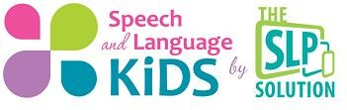 | EYFS KS1 KS2 | An extensive range of education and therapy resources for parents and teachers of children with speech and language problems. A podcast is also available on iTunes for verbal  and non-verbal children.
 | EYFS KS1 KS2 | A parent portal with links to downloadable resources, activities and games developed by a team of speech and language therapists and software engineers who work with over 4,000  schools in the UK.
 | EYFS KS1 KS2 | Online support and information aimed at supporting parents with young autistic children. Information and ideas to support the implementation of autism specific teaching  methods.

